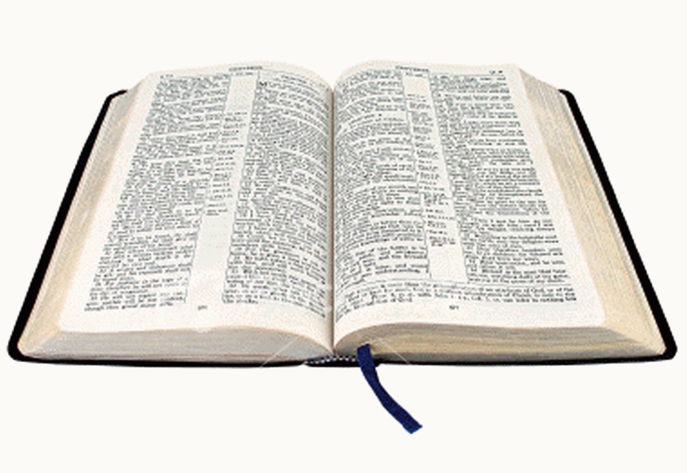
BELIEFS:
- The Bible is the inerrant Word of God
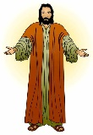

- Jesus Christ is the only begotten Son of God
- Jesus Christ was crucified for our sins and rose again on the third day

- One must believe in the Lord Jesus Christ and accept Him as our Lord and Savior
- The only way to salvation and Heaven is by faith in the Lord Jesus Christ

